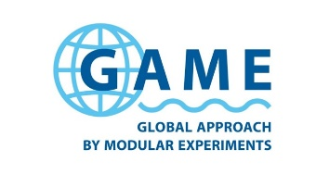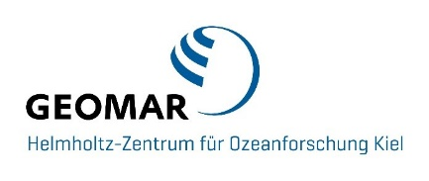

GAME 2024: Influence of artificial light at night on marine macroalgae
Worldwide, coastal areas are increasingly affected by artificial light at night (ALAN) that is emitted by human settlements, ships and nearshore constructions. Although, we know more and more about the negative consequences of these emissions for animals, we are basically unaware of their effects on macroalgae and other marine photoautotrophs. Macroalgae, in particular long-living and habitat-forming species, provide a wide range of vital ecosystem services for coastal habitats. In laboratory experiments, we tested whether nighttime exposure to white and yellow light at an intensity of 0.54 µmol/m²/sec (30 lux) alters the rate of biomass change and the attractiveness to grazers in 14 macroalgae species. The single experiments lasted for 2 to 3 weeks and were conducted at 8 sites worldwide. We found statistically significant effects for both response variables, while, however, the strength as well as the direction of the effects varied between study systems. This novel work indicates that anthropogenic light emissions can affect the performance and, as a consequence, potentially also the abundance of species from this important group of marine macrophytes.

GAME is a programme in research-based education and invites Master students to collect data for their theses within the framework of a global research project in marine ecology. The participants of the GAME project 2024 present results from their research on the effects of light pollution.

15.01.2025, 11:15, Universität Hamburg, Kowwigsaal, Zoologisches Institut
